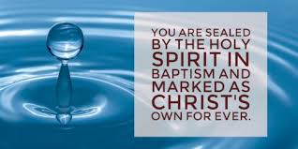

The Baptism Service

The Baptism can be offered at the following services:

- 1st Sunday: St. Cedd’s at 10.30 for Family Worship

- 2nd Sunday: St. Mary’s for Morning Prayer (No. H.C.) at which the Rector would be present for the Baptism but not at the start of the service as he would be at St. Cedd’s beforehand.

- 3rd Sunday: St. Mary’s at 11.15 – Holy Communion

- 4th Sunday: St. Cedd’s at 10.30 – Holy Communion

Exceptions will be made when candidates are part of the regular fellowship

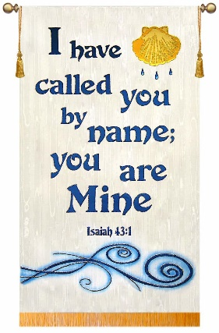

2019.08.01

The Parish of Stifford
St Mary and St Cedd

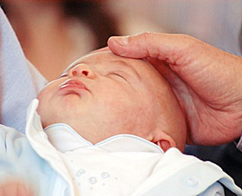

Thinking about a Baptism or Thanksgiving?

www.parishofstifford.co.uk

Parish of Stifford
Baptism and Thanksgiving

The Parish of Stifford welcomes all people – young and old – who come forward for Baptism. We believe that Baptism marks an important step in Christian commitment and so it is right that those to be baptised (or their parents in the case of a child) should have an understanding of its meaning.

The meaning of Baptism

Baptism is a 'sacrament': a visible sign of God's love. In baptism, we are thanking God for His gift of life, publicly acknowledging His love and promising to turn away from the darkness of evil and to make a new start with God.

For a child, baptism marks the start of a journey of faith, which involves turning away from the darkness of self-centeredness, turning towards Christ and becoming a member of the local and worldwide Christian family.
In baptism, parents start their child on the journey of faith and promise to give their child a Christian upbringing with the support of the church.

Thanksgiving Service

For parents who would prefer this approach, there is also the possibility of a service of Thanksgiving for the gift of a child. In this service, parents thank God for the gift of their child and the child is blessed. Parents do not make the same promises as in the baptism service. If parents choose to have a Thanksgiving they are free to have a Baptism service for their child at a later date.

Preparation for Baptism

For those seeking baptism for themselves or their child, there are two stages of preparation.

- Joining our Church worship on a regular basis.

- Baptism preparation meetings.

Church Etiquette

Our church family is very much aware that a Baptism Service is a time for families to come together to celebrate this important sacrament. However we would ask that the Baptism party and all their guests recognise and respect that this is primarily a service of worship and thanksgiving and that, for the regular members of our congregation, our time of being together for Sunday worship is also very special. Some people may not be used to being in church and may perhaps be a little apprehensive about attending a religious service, especially if it is for the first time, so we hope that the following guidelines will be helpful:

- Your service sheet will enable you to follow the proceedings step by step and the Rector will also advise when it is appropriate to stand or sit etc.
- One of the most important aspects of our worship is prayer and we would ask that during our prayer time we all respect the silence of the congregation – even whispering can be very disruptive during these quiet times.
- It probably goes without saying that all mobile phones and other technology should be switched off before the service starts but please make sure that your guests check them – just in case!
- Also, remembering that this is a religious service, please do not take photos during the service – there will be plenty of photo opportunities around the font after the service.
- We know that there may be a number of young children at the service and we have a small area of the church with books, quiet games etc. where parents may sit with their children if they prefer.
- The first 2 rows will be reserved for the main Baptism party and your other guests are invited to join the main congregation in the remaining pews. There will be a need for a limit on numbers, in either church, due to the space available.

It just remains for us to say that we really look forward to welcoming you and your guests to our church and we hope that you have a very memorable day.

Please contact the Rector to arrange a meeting 01375 372733

